IA RAS IHMC RAS MAE RAS IG RAS
Dep. of Education and Science of Bryansk Region Bryansk State University Bryansk State Museum of Local Lore 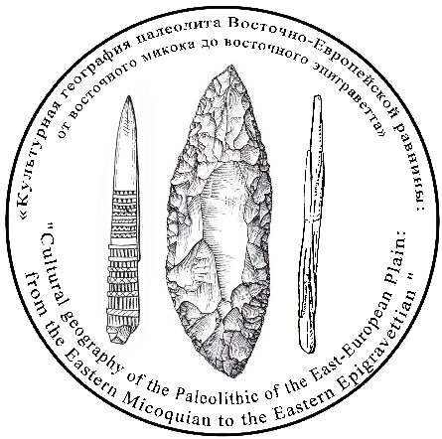

Conference / Field Workshop:
«Cultural geography of the Paleolithic of the East European Plain:
from the Micoquian to the Epigravettian»
from 10thto 16th September 2019

Registration Form
(please send it to desna2019@gmail.com until 28th February 2019)

Surname, name
Academic degree
Affiliation, city
Position
E-mail
Phone number
Preliminary topic of the presentation/poster
Co-authors (with affiliation and e-mail)
Form of the presentation (oral/poster)
Who of the authors is expected to come to the conference

